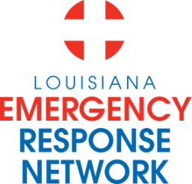

Louisiana Emergency Response Network Board Meeting
December 10, 2015
1:00pm – 3:00pm
Location: Louisiana Emergency Response Network - Headquarters
14141 Airline Hwy, Suite One, Suite B Baton Rouge, LA 70817

AGENDA
1. Welcome LERN Board Members
2. Roll Call and Establish a Quorum
3. Approval of Agenda
4. Approval of Minutes of 8/20 Board Meeting
5. LERN Business:

- Ratification of Commission Members (5 min) J. Hunt, MD

- Executive Director (25 min) P. Hargrove
  - Proposed Meeting Dates 2016
  - Board Officer Elections – 2/2016
  - Contracts (LCM and B S &W)
  - Ethics Training Reminder
  - Funding Options
- LERN Trauma Destination Protocol (10 min) W. Freeman, MD

- Level IV Trauma Centers (15 min) W. Freeman, MD

- Stroke System Update (15 min) Sheryl Martin-Schild, MD
- DNV accreditation

- STEMI System Update (10 min) Zee Ali, MD

- Trauma System Update (15 min) R. Coscia, MD
- State Trauma System Research
- EMS Registry

- SCR 42 Workgroup (10 min) Dr. Owings, MD

- Budget/Finance (10 min) P. Sullivan/C. Woods

6. Public Comment (5 min)
7. Adjournment
Next Board Meeting – February 18, 2016 (pending board approval)

